# 1.jpg

Database 2 Group Assignment Cover Sheet

**IT7005 Database Systems 2**

**Assessment Title:**

**ICT**

**Programme Title:**

**IT7005**

**Course No.:**

**Database Systems 2**

**Course Title:**

**Noora Qasim, Fatema Naser, Maryam Saleh**

**Student Names:**

**Student IDs:**

Introduction 2

ERD 3

Relationship between entities: 4

Triggers explanation 6

Functions explanation 8

Procedures explanation 12

Packages explanation 16

Views 19

DDL Commands 20

Creating indexes 22

Creating Sequences 23

Creating views 23

CREATE TRIGGERS 24

CREATE FUNCTIONS 26

CREATE PROCEDURES 27

DCL Commands 31

DML Commands 31

## Introduction

Our system was designed for a car rental company to work as a database system to save all the information about the company, its cars, locations, manufacturers, and rentals. Moreover, it simplifies and automates many functions and procedures involved in the car rental process. It displays the services the company provides, making it easier and more convenient for the employees to track data and monitor it. With the use of this system, reporting and making decisions based on the information stored and maintained are made simpler and quicker.

## ERD

The ERD consists of 10 entities. Here’s an overview of each entity

1. Car_rental   
   - This table contains details for each car rental which include drop off location and pick up location, car category etc. If extra specific information is needed, it can be accessed through this entity, as it is connected to all the entities in some way.
2. Rental_status  
   - This table contains the details of the rental, meaning if the rented car is returned it will store the time, and if the rented car has any complication it will be stored there. In short, it contains all information needed about the current status of the rented car.
3. Location  
   - This table contains the information of the location of the offices.
4. Customer  
   - This table contains all the information of the customers. Includes details like name, address, phone number, CPR, email etc.
5. Car  
   - This table contains all the details about the car. Includes details like the daily rate, mileage , colour of the car etc.
6. Car_category   
   - This table contains more general data about the type of car: economy, luxury, and SUV.
7. Model  
   - This table contains more specific data about the model of the car like the year , engine size etc.
8. Manufacturer   
   - This table contains details about the manufacturer like their office location and working hours.
9. Extra_equipment   
   - This entity contains information about extra equipment like car seats, gps. Information includes quantity in stock and type of extra equipment.
10. Rental_equipment   
    - This entity was made to resolve a many to many relationship between Extra_equipment and car_rental. The logic behind the many to many relationship is that one car rental can request more than one extra equipment per car rental.

## Relationship between entities:

1. Car and model:

* The relationship is a one-to-one (or zero) relationship, meaning that each car has one model, and each model is associated with a single car. To establish this one-to-one (or zero) relationship, a foreign key is added to the car entity, referencing the primary key of the Model table. This foreign key ensures that each car record is linked to a specific model.

1. Model and Manufacturer :

* The relationship is one to many relationship, meaning that each Manufacturer can have multiple models, whereas each model can belong only to one manufacturer. A foreign key is added in the model table, referencing the primary key of the manufacturer. This ensures that each model is linked to a manufacturer.

1. Car_Category and Car:

* The relationship is one to many relationship, meaning that each Car category can have multiple cars, whereas each car can belong only to one car category. A foreign key is added in the car table, referencing the primary key of the car category table. This ensures that each car is linked to a car category.

1. Car_rental and Car

* The relationship is one to many relationship, meaning that each Car can have multiple car rentals, whereas each car rental can belong to only one car. A foreign key is added in the Car rental table, referencing the primary key of the car table. This ensures that each car rental is linked to a car.

1. Car_rental and location

* The relationship is one to many relationship, meaning that each location can have multiple car rentals, whereas each car rental can belong to only one location; as cars should be picked up and dropped off in the same location. A foreign key is added in the Car rental table, referencing the primary key of the location table. This ensures that each car rental is linked to a location.

1. Car_rental and rental_status

* The relationship is a one-to-one relationship, meaning that each car rental has one rental status associated with it, and each car rental status is associated with a single car rental. To establish this one-to-one (or zero) relationship, a foreign key is added to the car rental entity, referencing the primary key of the rental status table. This foreign key ensures that each car rental record is linked to a specific rental status that describes its current status.

1. Car rental and customer

* The relationship is one to many relationship, meaning that each customer can have multiple car rentals, whereas each car rental can belong to only one customer. A foreign key is added in the Car rental table, referencing the primary key of the customer table. This ensures that each car rental is linked to a customer.

1. Car rental and extra equipment

* The relationship was a many to many relationship which was resolved by introducing a composite entity called Rental_Equipment which acts as a bridge between those two entities. It contains two primary foreign keys : one referencing the primary key in the car_rental and other to the primary key in extra_equipment. It also contains the quantity of the rental equipment that was rented for this specific car rental and this specific extra_equipment.

## Triggers explanation

1–Status_update_trigger

* This trigger status_update_trigger updates the status depending on the status description, the trigger will fire after an insert or update on the rental_status if the new status is completed, then an update on the car table in the status attribute will change to available. On the other hand if the new status is Rented then an update on the car table in the status attribute will change to Rented. Along with the trigger code attached we have used this statement to test it and here is the outcome:
* 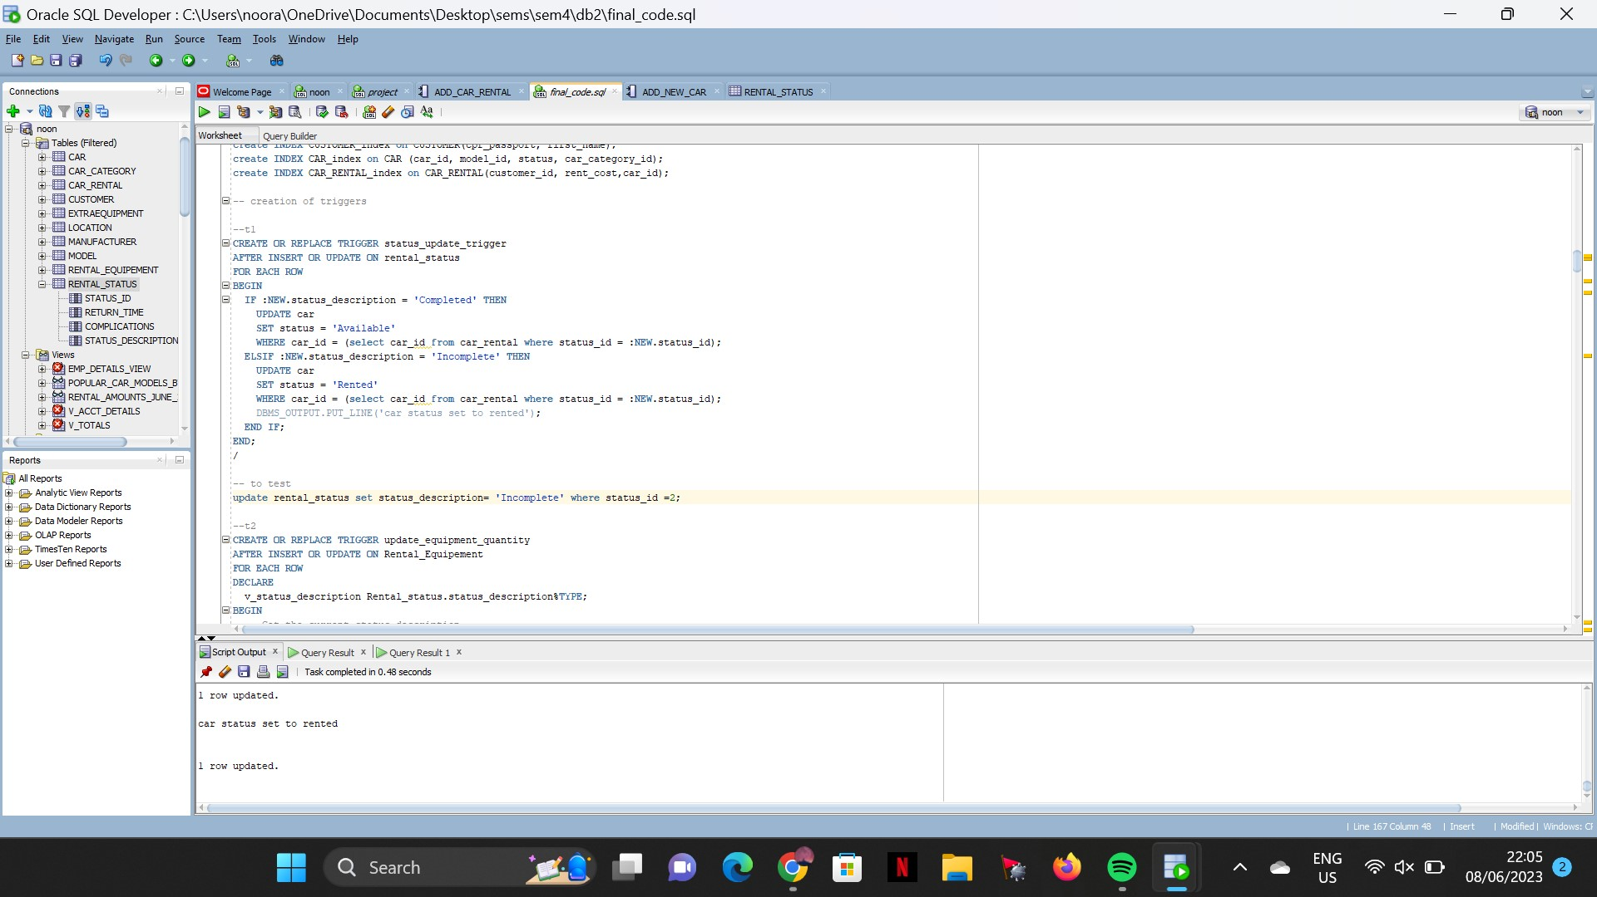

2-update_equipment_quantity

* The trigger update_equipment_quantity is used to update the quantity of the equipment in the extra equipment table based on the update in the status_id and the status description in the rental status table.

It retrieves the status_description from the Rental_Status table based on the Car_Rental_ID of the new row. If it is an insert operation, it subtracts the quantity of the new row from the Quantity column in the ExtraEquipment table for the corresponding Extra_Equipment_ID. If it is an update operation on the 'status_id' column and the status_description is 'complete', it adds the quantity from the ExtraEquipment table to the Quantity column in the Rental_Equipment table for the corresponding Car_Rent_ID, Car_Rental_ID, and Extra_Equipment_ID.

3- calculate_rental_cost

* The trigger calculate_rental_cost is fired to calculate the overall rent cost. First it calculates the cost of the extra equipment based on cost and quantity for each equipment. Then we fetch the daily hire rate of the car, in the end we calculate the overall rent cost by a mathematical equation that uses calculations of the extra equipment, hire rate, duration and penalty costs.

4-Insert_Rental_Status

The trigger Insert_Rental_Status is called before an insert on the car_rental table. It generates a new status id using the Rental_Status_SEQ sequence, then inserts a new rental status record in the Rental_Status table with the following values: the generated status ID, default values for Return_Time, complications, and status_description). Finally, it sets the status_id column of the new row in the Car_Rental table to the generated status ID. This is made to ensure that when the car rental is inserted it maintains integrity

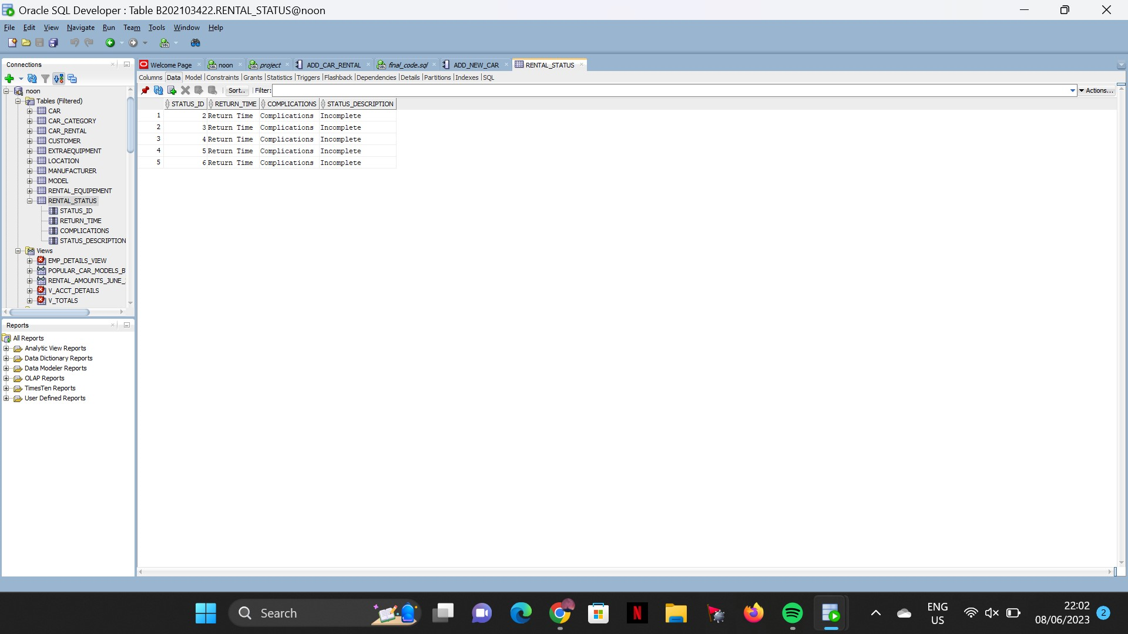

## Functions explanation

1. Calculate_Profit_per_month(year,month)

* This function will take in the year and month passed by the user as parameters. And will return back the total profit of car rentals for that specific month and year. Along with the code attached we have tested it using this snippet:

##### set serveroutput on;

##### DECLARE

##### V_RESULT NUMBER;

##### BEGIN

##### V_RESULT := Calculate_Profit_Per_Month(2022,6);

##### dbms_output.put_line(v_result || ' profit in june 2022');

##### END;

##### /

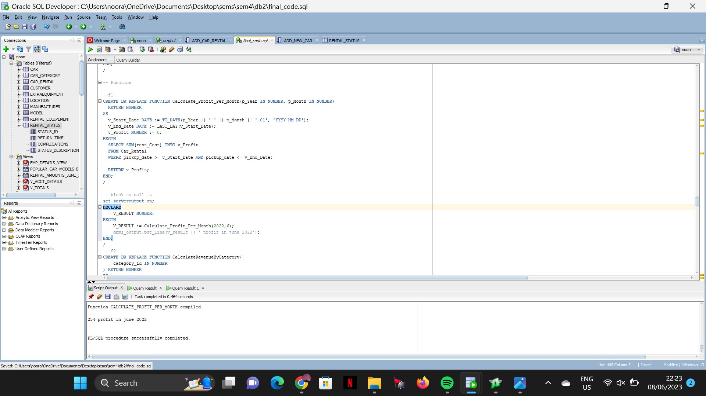

The following output is seen

1. CalculateRevenueByCategory(Category_id)

* This function will take in the category id as a parameter passed on by the user. It will return back the total revenue by that category. Along with the code attached at the bottom, this snippet was used to test it

##### DECLARE

##### V_RESULT NUMbER;

##### V_result2 number;

##### V_result3 number;

##### BEGIN

##### V_RESULT := CalculateRevenueByCategory(1);

##### v_result2 := CalculateRevenueByCategory(2);

##### v_result3 := CalculateRevenueByCategory(3);

##### DBMS_OUTPUT.PUT_LINE(V_RESULT || ' total revenue by category 1');

##### DBMS_OUTPUT.PUT_LINE(V_RESULT2 || ' total revenue by category 2');

##### DBMS_OUTPUT.PUT_LINE(V_RESULT3 || ' total revenue by category 3');

##### END;

##### /

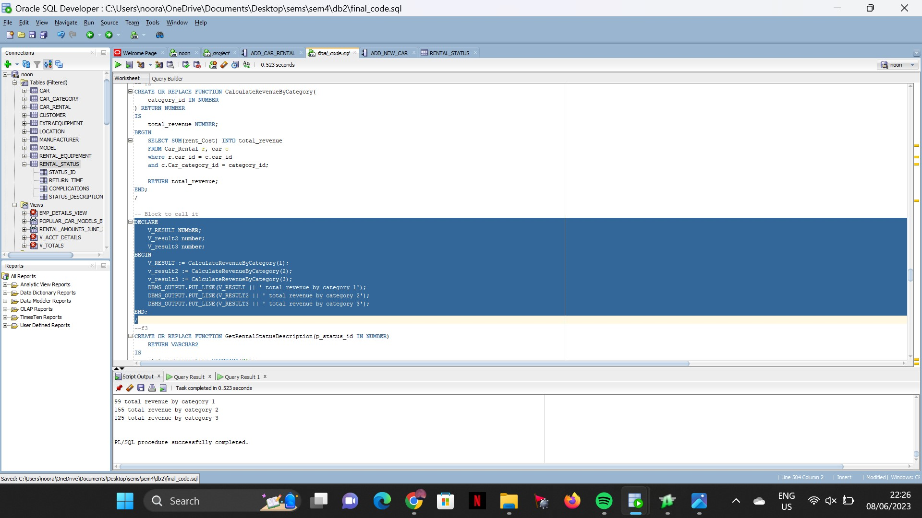

The following output can be seen

1. GetRentalStatusDescription(status_id)

* This function will take in the status id as a parameter passed by the user. And will return the status description of that particular status id. Also, this function will handle the error if the data is not found and will return nothing. The following snippet was used to test the function.

##### set serveroutput on;

##### DECLARE

##### status_id number := (&status_id);

##### res varchar2(100);

##### BEGIN

##### res := GetRentalStatusDescription(status_id);

##### dbms_output.put_line(res);

##### END;

##### /

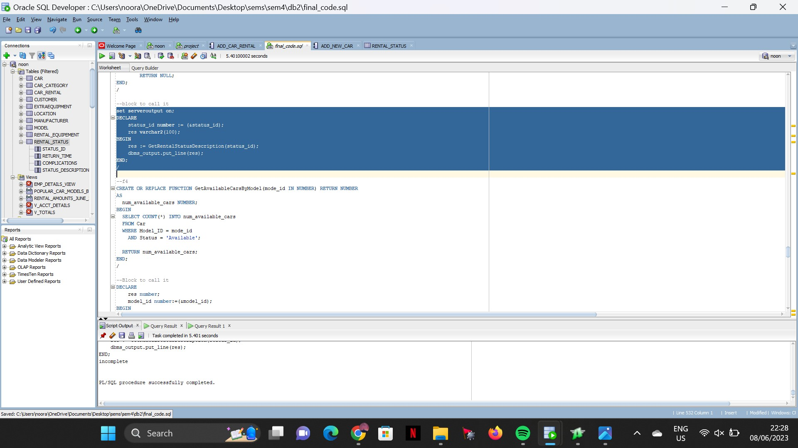

1. GetAvailableCarsByModel(Model_id)

* This function will take in the model id that is passed by the user as a parameter. And will return back the number of cars of that model which have their status description as ‘Available’. The following block was used to test the code.

##### DECLARE

##### res number;

##### model_id number:=(&model_id);

##### BEGIN

##### res:= GETAVAILABLECARSBYMODEL(model_id);

##### dbms_output.put_line(res || ' available cars');

##### END;

##### /

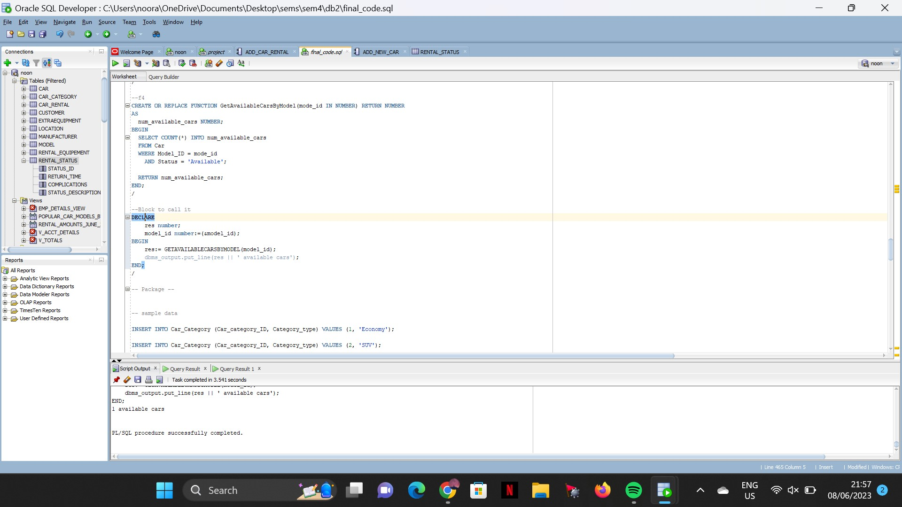

## Procedures explanation

1- Add_Customer

* The procedure Add_Customer is used to add new customers by inserting into the customer table multiple values like customer ID, nationality, first name, phone number, address, gender, date of birth, email, and CPR/passport number. The following block was used to test the procedure.

##### DECLARE

##### v_Nationality VARCHAR2(100) := ('&Nationality');

##### v_First_Name VARCHAR2(100) := ('&firstname');

##### v_Phone_Number VARCHAR2(100) := ('&phone');

##### v_Address VARCHAR2(100) := ('&address');

##### v_House_Number NUMBER := (&housenumber);

##### v_Road NUMBER := (&road);

##### v_Add_Block NUMBER := (&block);

##### v_Gender VARCHAR2(100) := ('&Gender');

##### v_DOB DATE := TO_DATE(('&date'), 'YYYY-MM-DD');

##### v_Email VARCHAR2(100) := ('&email');

##### v_CPR_Passport NUMBER := (&passport);

##### BEGIN

##### 

##### ADD_CUSTOMER( v_Nationality,v_First_Name,v_Phone_Number,v_Address,v_House_Number,v_Road,v_Add_Block,v_Gender,v_DOB,v_Email,v_CPR_Passport);

##### 

##### END;

##### /

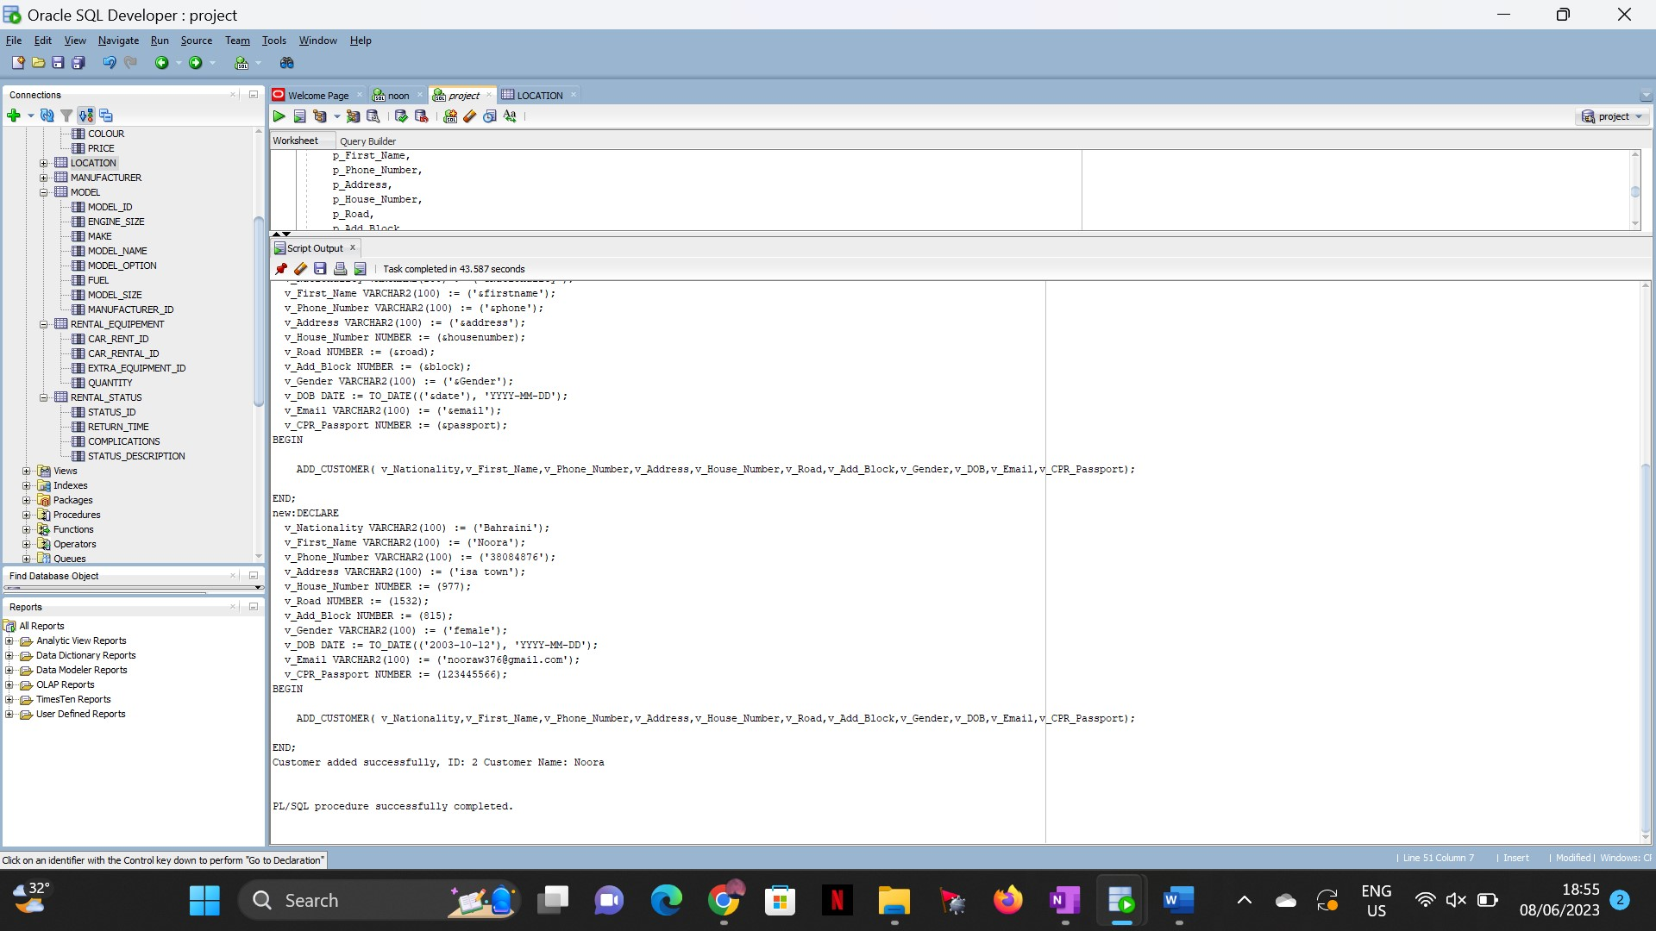

2- Count_Rentals_Per_Month:

* The procedure Count_Rentals_Per_Month is used to count the number of rentals each month. It takes the count of values from the car_rental table and stores it in a variable named p_Num_Rentals based on the year and month.

##### DECLARE

##### p_Year number := 2022;

##### p_Month number := 6;

##### p_Num_Rentals number;

##### BEGIN

##### Count_Rentals_Per_Month(p_Year,p_Month,p_Num_Rentals);

##### dbms_output.put_line(p_Num_Rentals);

##### END;

##### /

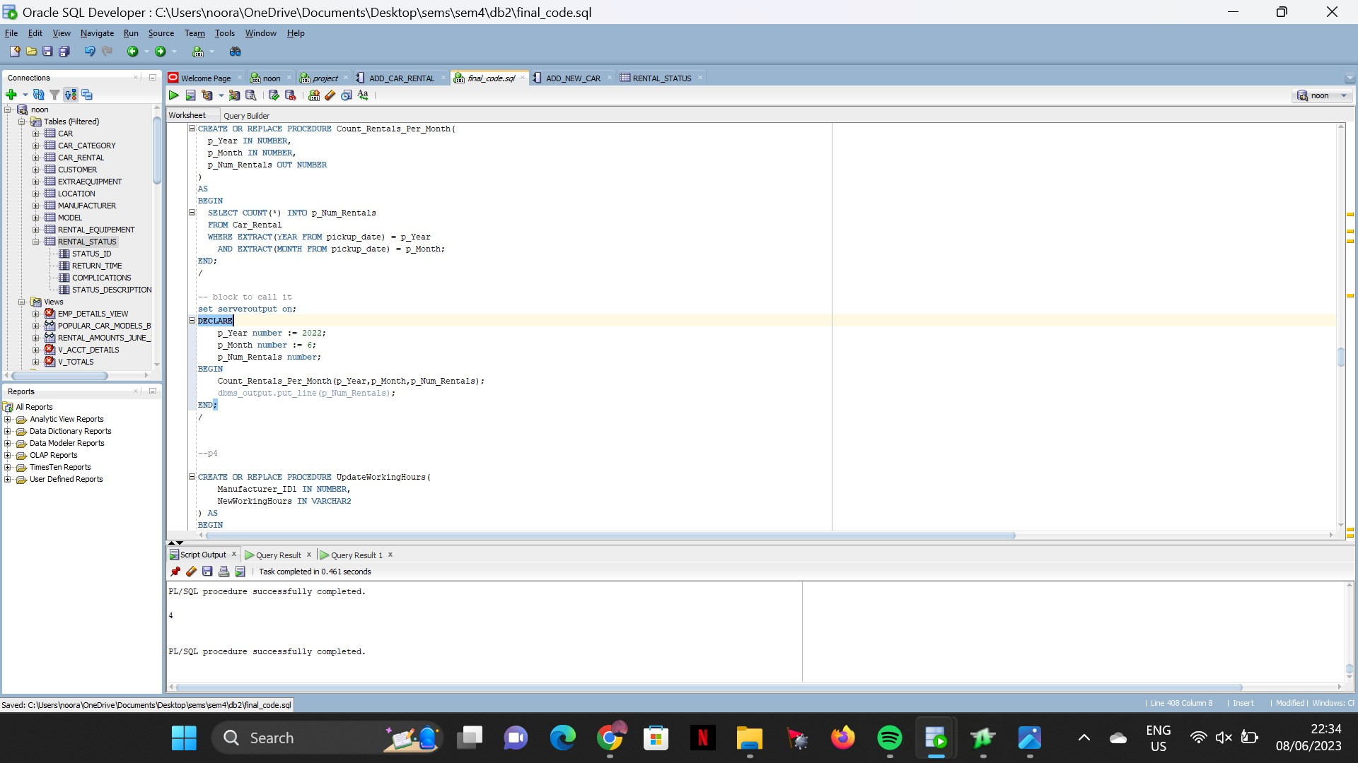

3- Add_Car

This procedure will take in all the car details and will add it to the table by inserting multiple data at once and creating a record in the car table .

##### --block to call it

##### DECLARE

##### car_id1 NUMBER := 233223 ;

##### red_due_date DATE := SYSDATE;

##### insured1 VARCHAR2(100) := 'yes';

##### color VARCHAR2(50) := 'red';

##### mil NUMBER := 50000;

##### status VARCHAR2(50) := 'available';

##### d_hire NUMBER := 50;

##### return1 NUMBER := 20;

##### car_cat NUMBER := 1;

##### model1 NUMBER := 2;

##### BEGIN

##### add_new_car(

##### car_id1,red_due_date,insured1,color,mil,status,d_hire,return1,car_cat,model1

##### );

##### EXCEPTION

##### WHEN OTHERS THEN

##### DBMS_OUTPUT.PUT_LINE('Error: ' || SQLERRM);

##### END;

##### /

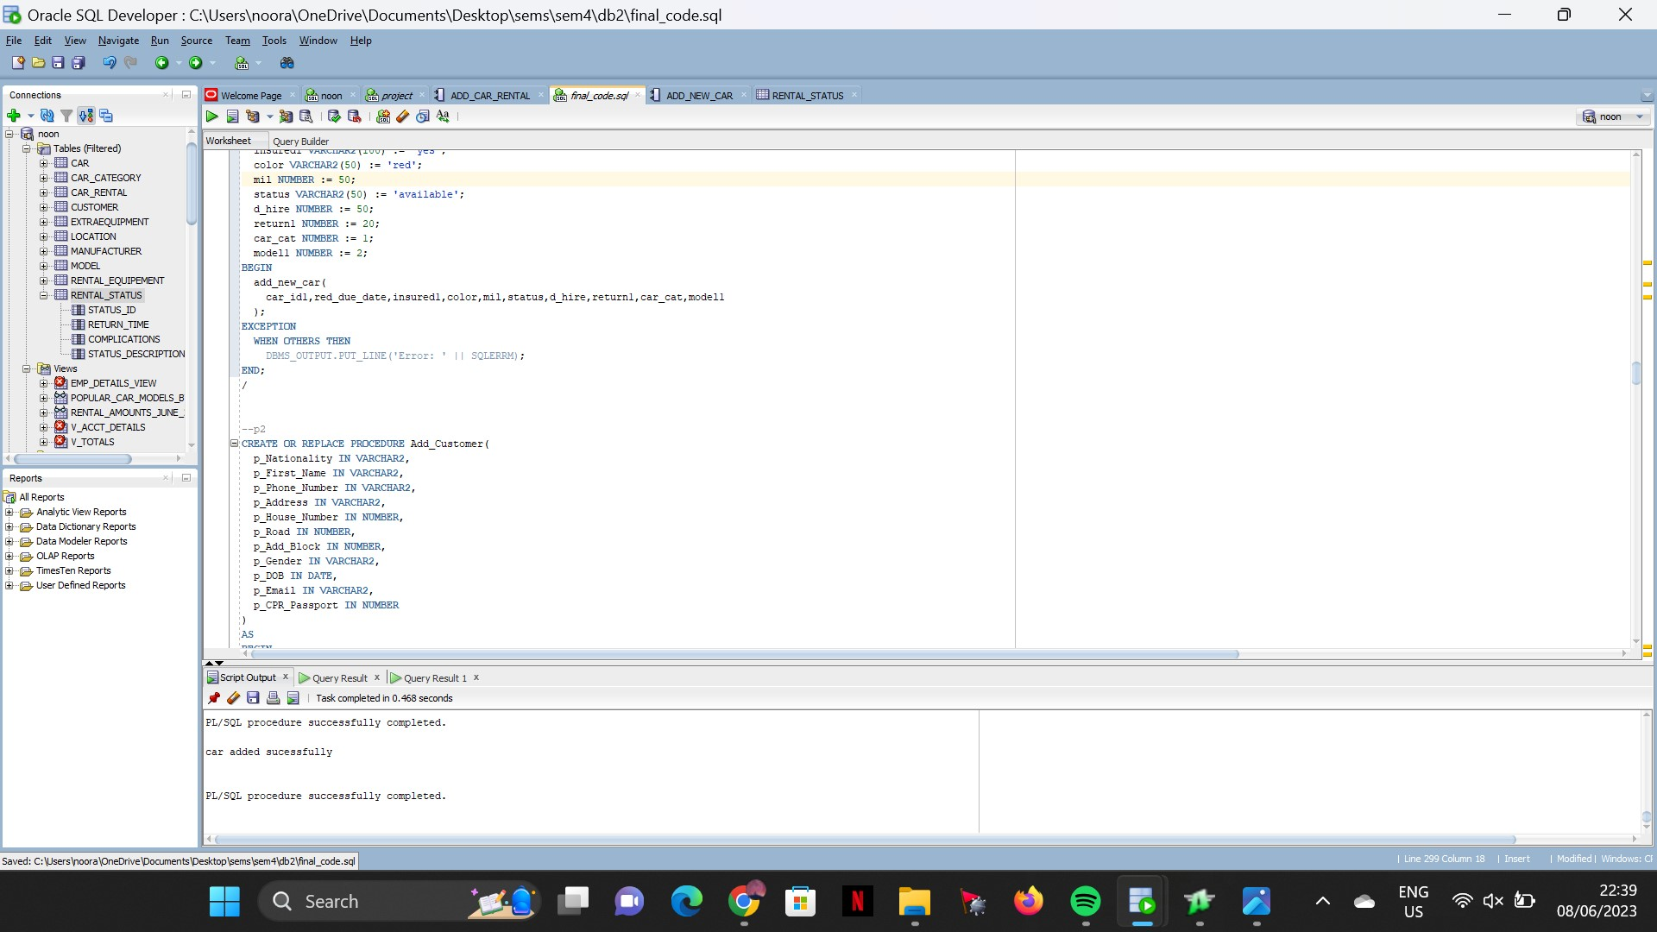

4- Update working hours

The procedure UpdateWorkingHours is used to update the working hours for the manufacturer based on the manufacturer id. It takes the manufacturer id entered and updates the working hours for that specific manufacturer id. The following block was used to test the procedure.

##### -- block to call it

##### BEGIN

##### UpdateWorkingHours(1, '9:00 AM - 5:00 PM');

##### END;

##### /

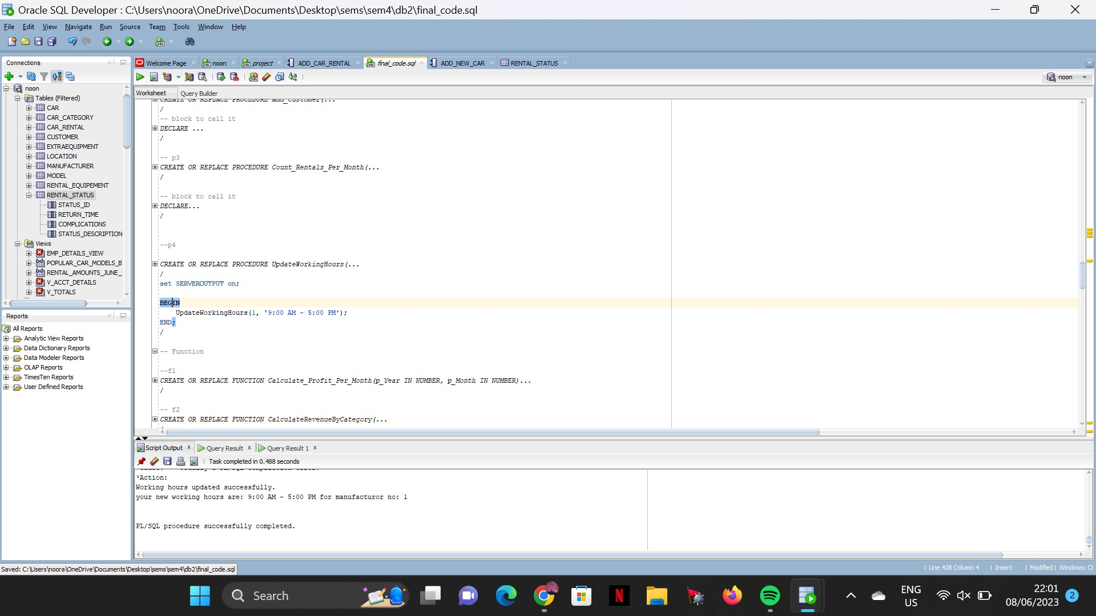

## Packages explanation

The package rentals contains different procedures and functions related to rental operations.

Functions included in this package is:CalculateProfitPerMonth, CalculateRevenueByCategory, GetRentalStatusDescription

Procedures included in this package are: CountRentalsPerMonth

##### CREATE OR REPLACE PACKAGE rentals

##### IS

##### PROCEDURE CountRentalsPerMonth(month IN NUMBER, year IN NUMBER, rental_count OUT NUMBER);

##### 

##### FUNCTION CalculateProfitPerMonth(month IN NUMBER, year IN NUMBER) RETURN NUMBER;

##### 

##### FUNCTION CalculateRevenueByCategory(category_id IN NUMBER) RETURN NUMBER;

##### 

##### FUNCTION GetRentalStatusDescription(status_id IN NUMBER) RETURN VARCHAR2;

##### 

##### END rentals;

##### /

##### Package body

##### CREATE OR REPLACE PACKAGE BODY rentals

##### IS

##### PROCEDURE Count_Rentals_Per_Month(

##### p_Year IN NUMBER,

##### p_Month IN NUMBER,

##### p_Num_Rentals OUT NUMBER

##### )

##### AS

##### BEGIN

##### SELECT COUNT(*) INTO p_Num_Rentals

##### FROM Car_Rental

##### WHERE EXTRACT(YEAR FROM pickup_date) = p_Year

##### AND EXTRACT(MONTH FROM pickup_date) = p_Month;

##### END;

##### 

##### FUNCTION Calculate_Profit_Per_Month(p_Year IN NUMBER, p_Month IN NUMBER)

##### RETURN NUMBER

##### AS

##### v_Start_Date DATE := TO_DATE(p_Year || '-' || p_Month || '-01', 'YYYY-MM-DD');

##### v_End_Date DATE := LAST_DAY(v_Start_Date);

##### v_Profit NUMBER := 0;

##### BEGIN

##### SELECT SUM(rent_Cost) INTO v_Profit

##### FROM Car_Rental

##### WHERE pickup_date >= v_Start_Date AND pickup_date <= v_End_Date;

##### 

##### RETURN v_Profit;

##### END;

##### 

##### FUNCTION CalculateRevenueByCategory(

##### category_id IN NUMBER

##### ) RETURN NUMBER

##### IS

##### total_revenue NUMBER;

##### BEGIN

##### SELECT SUM(rent_Cost) INTO total_revenue

##### FROM Car_Rental r, car c

##### where r.car_id = c.car_id

##### and c.Car_category_id = category_id;

##### 

##### RETURN total_revenue;

##### END;

##### 

##### FUNCTION GetRentalStatusDescription(p_status_id IN NUMBER)

##### RETURN VARCHAR2

##### IS

##### status_description VARCHAR2(20);

##### BEGIN

##### SELECT status_description INTO status_description

##### FROM Rental_status

##### WHERE status_id = p_status_id;

##### 

##### RETURN status_description;

##### EXCEPTION

##### WHEN NO_DATA_FOUND THEN

##### RETURN NULL;

##### END;

##### 

##### 

##### END;

## Views

Code presented at the end of the report

Q1) we counted the number of rentals based on model id and location, we have used a HAVING clause to only display the maximum

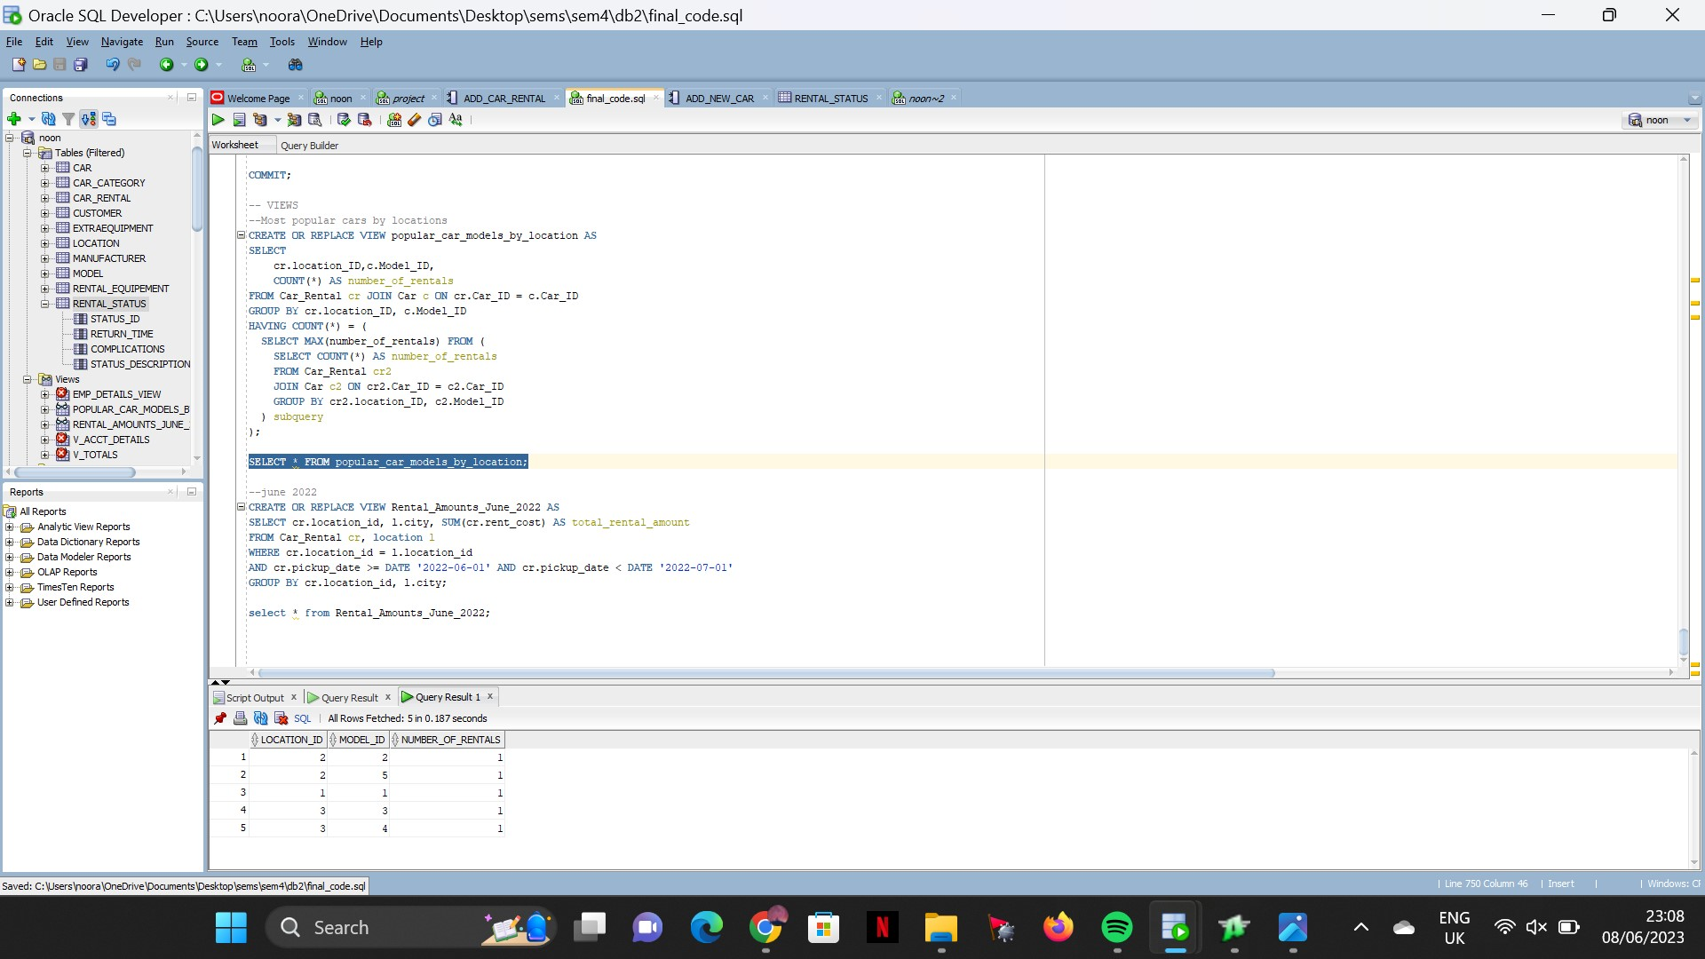

Q2) used the where clause to join both location and car rental, and used a statement to filter the data to only between the first of june and before the start of july.

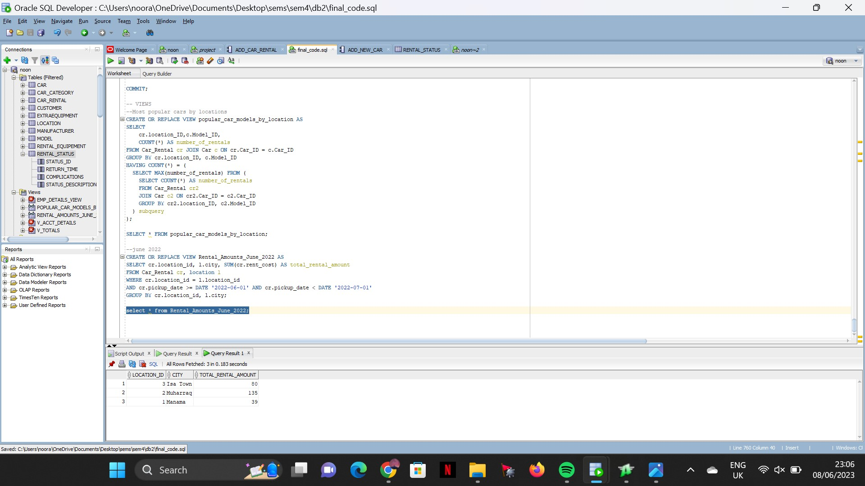

##### 

## DDL Commands

The following text is the code that was used to add tables, their attributes, and constraints to the schema.

Create table Car_Category

(Car_category_ID Numeric(10) primary key,

Category_type VARCHAR2(30));

**--Create tables --**

CREATE TABLE Manufacturer (

Manufacturer_ID NUMERIC(10) NOT NULL PRIMARY KEY,

m_Name VARCHAR2(25) NOT NULL,

Phone_Number VARCHAR2(15) NOT NULL,

Office_address VARCHAR2(30) NOT NULL,

Working_hours VARCHAR2(20) NOT NULL

);

CREATE TABLE Model (

Model_ID NUMERIC(10) NOT NULL PRIMARY KEY,

Engine_Size VARCHAR2(15) NOT NULL,

Make VARCHAR2(15) NOT NULL,

Model_Name VARCHAR2(15) NOT NULL,

model_Option VARCHAR2(15) NOT NULL,

Fuel VARCHAR2(15) NOT NULL,

model_Size VARCHAR2(15) NOT NULL,

Manufacturer_ID NUMERIC(10) NOT NULL,

Constraint man_fk FOREIGN KEY (Manufacturer_ID) REFERENCES Manufacturer (Manufacturer_ID)

);

CREATE TABLE ExtraEquipment (

Extra_Equipment_ID NUMERIC(10) NOT NULL PRIMARY KEY,

equipment_Type VARCHAR2(30) NOT NULL,

Quantity NUMERIC(5) NOT NULL,

colour VARCHAR2(15) NOT NULL,

Price NUMBER(10,2) NOT NULL

);

CREATE TABLE Customer (

Customer_ID NUMERIC(10) NOT NULL PRIMARY KEY,

Nationality VARCHAR2(15) NOT NULL,

First_name VARCHAR2(25) NOT NULL,

Phone_Number VARCHAR2(15) NOT NULL,

Address VARCHAR2(35) NOT NULL,

house_number NUMERIC(10) NOT NULL,

Road NUMERIC(5) NOT NULL,

add_Block NUMERIC(5) NOT NULL,

Gender VARCHAR2(10) NOT NULL,

DOB DATE NOT NULL,

Email VARCHAR2(30) NOT NULL,

CPR_Passport NUMERIC(20) NOT NULL

);

CREATE TABLE Rental_status (

status_id NUMERIC(5) NOT NULL PRIMARY KEY,

Return_Time VARCHAR2(20) NOT NULL,

complications VARCHAR2(20) NOT NULL,

status_description VARCHAR2(10) NOT NULL

);

CREATE TABLE Car (

Car_ID NUMERIC(10) NOT NULL PRIMARY KEY,

Registration_due_date DATE NOT NULL,

Insured VARCHAR2(15) NOT NULL,

Colour VARCHAR2(15) NOT NULL,

Mileage NUMBER(5,2) NOT NULL,

Status VARCHAR2(15) NOT NULL,

Daily_hire_rate NUMBER(5,2) NOT NULL,

return_penalty NUMBER(5,2) NOT NULL,

Car_Category_ID NUMERIC(10) NOT NULL,

Model_ID NUMERIC(10) NOT NULL,

Constraint model_fk FOREIGN KEY (Model_ID) REFERENCES Model (Model_ID),

Constraint category_fk FOREIGN KEY (Car_Category_ID) REFERENCES Car_category (Car_Category_ID)

);

CREATE TABLE Location (

location_ID NUMERIC(10) NOT NULL PRIMARY KEY,

phone_number VARCHAR2(15) NOT NULL,

Building VARCHAR2(5) NOT NULL,

City VARCHAR2(10) NOT NULL,

Address VARCHAR2(15) NOT NULL

);

CREATE TABLE Car_Rental (

Car_Rental_ID NUMERIC(10) NOT NULL PRIMARY KEY,

Car_category VARCHAR2(25) NOT NULL,

rent_Duration VARCHAR2(25) NOT NULL,

rent_Cost NUMBER(5,2) NOT NULL,

rent_Penalty NUMBER(5,2) NOT NULL,

Car_ID NUMERIC(10) NOT NULL,

Customer_ID NUMERIC(10) NOT NULL,

status_id NUMERIC NOT NULL,

location_ID NUMERIC(10) NOT NULL,

pickup_date DATE NOT NULL,

Constraint car_fk FOREIGN KEY (Car_ID) REFERENCES car (Car_ID),

Constraint cust_fk FOREIGN KEY (Customer_ID) REFERENCES customer (Customer_ID),

Constraint status_fk FOREIGN KEY (status_id) REFERENCES rental_status (status_id),

Constraint location_fk FOREIGN KEY (location_ID) REFERENCES location (location_ID)

);

CREATE TABLE Rental_Equipement (

Car_Rent_ID NUMERIC(10) NOT NULL,

Car_Rental_ID NUMERIC(10) NOT NULL,

Extra_Equipment_ID NUMERIC(10) NOT NULL,

Quantity NUMERIC(2) NOT NULL,

CONSTRAINT Car_Rent_ID PRIMARY KEY (Car_Rent_ID, Car_Rental_ID, Extra_Equipment_ID)

);

### Creating indexes

**--creation of indexes**

create INDEX MODEL_index on MODEL (make, model_name);

create INDEX EXTRAEQUIPMENT_index on EXTRAEQUIPMENT (equipment_type);

create INDEX CUSTOMER_index on CUSTOMER(cpr_passport, first_name);

create INDEX CAR_index on CAR (car_id, model_id, status, car_category_id);

create INDEX CAR_RENTAL_index on CAR_RENTAL(customer_id, rent_cost,car_id);

### Creating Sequences

**-- creation of sequences**

create sequence MANUFACTURER_seq start with 1 increment by 1 nocycle;

create sequence EXTRA_EQUIPMENT_seq start with 1 increment by 1 nocycle;

create sequence CUSTOMER_seq start with 1 increment by 1 nocycle;

create sequence RENTAL_STATUS_seq start with 1 increment by 1 nocycle;

create sequence LOCATION_seq start with 1 increment by 1 nocycle;

create sequence CAR_RENTAL_seq start with 1 increment by 1 nocycle;

create sequence RENTAL_EQUIPEMENT_seq start with 1 increment by 1 nocycle;

### Creating views

**– Most popular model of cars by locations**

CREATE OR REPLACE VIEW popular_car_models_by_location AS

SELECT

cr.location_ID,c.Model_ID,

COUNT(*) AS number_of_rentals

FROM Car_Rental cr JOIN Car c ON cr.Car_ID = c.Car_ID

GROUP BY cr.location_ID, c.Model_ID

HAVING COUNT(*) = (

SELECT MAX(number_of_rentals) FROM (

SELECT COUNT(*) AS number_of_rentals

FROM Car_Rental cr2

JOIN Car c2 ON cr2.Car_ID = c2.Car_ID

GROUP BY cr2.location_ID, c2.Model_ID

) subquery

);

SELECT * FROM popular_car_models_by_location;

**--june 2022**

CREATE OR REPLACE VIEW Rental_Amounts_June_2022 AS

SELECT cr.location_id, l.city, SUM(cr.rent_cost) AS total_rental_amount

FROM Car_Rental cr, location l

WHERE cr.location_id = l.location_id

AND cr.pickup_date >= DATE '2022-06-01' AND cr.pickup_date < DATE '2022-07-01'

GROUP BY cr.location_id, l.city;

### CREATE TRIGGERS

**– creation of triggers**

**--t1**

CREATE OR REPLACE TRIGGER status_update_trigger

AFTER INSERT OR UPDATE ON rental_status

FOR EACH ROW

BEGIN

IF :NEW.status_description = 'Completed' THEN

UPDATE car

SET status = 'Available'

WHERE car_id = (select car_id from car_rental where status_id = :NEW.status_id);

ELSIF :NEW.status_description = 'Incomplete' THEN

UPDATE car

SET status = 'Rented'

WHERE car_id = (select car_id from car_rental where status_id = :NEW.status_id);

DBMS_OUTPUT.PUT_LINE('car status set to rented');

END IF;

END;

/

**--t2**

CREATE OR REPLACE TRIGGER update_equipment_quantity

AFTER INSERT OR UPDATE ON Rental_Equipement

FOR EACH ROW

DECLARE

v_status_description Rental_status.status_description%TYPE;

BEGIN

-- Get the current status_description

SELECT status_description INTO v_status_description

FROM Rental_status

WHERE status_id = :new.Car_Rental_ID;

-- Subtract the Quantity from Rental_Equipement from the Quantity in ExtraEquipment

IF INSERTING THEN

UPDATE ExtraEquipment

SET Quantity = Quantity - :new.Quantity

WHERE Extra_Equipment_ID = :new.Extra_Equipment_ID;

END IF;

-- Add the Quantity from ExtraEquipment to the Quantity in Rental_Equipement if status_description is 'complete'

IF UPDATING('status_id') AND v_status_description = 'complete' THEN

UPDATE Rental_Equipement

SET Quantity = Quantity + (SELECT Quantity FROM ExtraEquipment WHERE Extra_Equipment_ID = :new.Extra_Equipment_ID)

WHERE Car_Rent_ID = :new.Car_Rent_ID

AND Car_Rental_ID = :new.Car_Rental_ID

AND Extra_Equipment_ID = :new.Extra_Equipment_ID;

END IF;

END;

/

**--t3**

CREATE OR REPLACE TRIGGER calculate_rental_cost

BEFORE INSERT OR UPDATE ON Car_Rental

FOR EACH ROW

DECLARE

equipment_cost NUMBER := 0;

daily_hire_rate NUMBER;

BEGIN

-- Calculate the cost of extra equipment based on the rental equipment and quantity

FOR equip IN (SELECT Extra_Equipment_ID, Quantity

FROM Rental_Equipement

WHERE Car_Rental_ID = :new.Car_Rental_ID)

LOOP

SELECT Price INTO equipment_cost

FROM ExtraEquipment

WHERE Extra_Equipment_ID = equip.Extra_Equipment_ID;

equipment_cost := equipment_cost + (equip.Quantity * equipment_cost);

END LOOP;

-- Fetch the daily hire rate for the car

SELECT Daily_hire_rate INTO daily_hire_rate

FROM Car

WHERE Car_ID = :new.Car_ID;

-- Calculate the total rental cost

:new.rent_Cost := (:new.rent_Duration * daily_hire_rate) + equipment_cost + :new.rent_Penalty;

END;

/

**-- t4**

CREATE OR REPLACE TRIGGER Insert_Rental_Status

BEFORE INSERT ON Car_Rental

FOR EACH ROW

DECLARE

v_Status_ID NUMBER;

BEGIN

-- Generate a new status ID

SELECT Rental_Status_SEQ.NEXTVAL INTO v_Status_ID FROM DUAL;

-- Insert a new rental status record

INSERT INTO Rental_Status (status_id, Return_Time, complications, status_description)

VALUES (v_Status_ID, 'Return Time', 'Complications', 'Incomplete');

-- Set the status ID for the new rental agreement

:NEW.status_id := v_Status_ID;

END;

/

### CREATE FUNCTIONS

**-- Creation of function**

**– Function 1**

CREATE OR REPLACE FUNCTION Calculate_Profit_Per_Month(p_Year IN NUMBER, p_Month IN NUMBER)

RETURN NUMBER

AS

v_Start_Date DATE := TO_DATE(p_Year || '-' || p_Month || '-01', 'YYYY-MM-DD');

v_End_Date DATE := LAST_DAY(v_Start_Date);

v_Profit NUMBER := 0;

BEGIN

SELECT SUM(rent_Cost) INTO v_Profit

FROM Car_Rental

WHERE pickup_date >= v_Start_Date AND pickup_date <= v_End_Date;

RETURN v_Profit;

END;

/

**– Function 2**

CREATE OR REPLACE FUNCTION CalculateRevenueByCategory(

category_id IN NUMBER

) RETURN NUMBER

IS

total_revenue NUMBER;

BEGIN

SELECT SUM(rent_Cost) INTO total_revenue

FROM Car_Rental r, car c

where r.car_id = c.car_id

and c.Car_category_id = category_id;

RETURN total_revenue;

END;

/

**– Function 3**

CREATE OR REPLACE FUNCTION GetRentalStatusDescription(p_status_id IN NUMBER)

RETURN VARCHAR2

IS

status_description VARCHAR2(20);

BEGIN

SELECT status_description INTO status_description

FROM Rental_status

WHERE status_id = p_status_id;

RETURN status_description;

EXCEPTION

WHEN NO_DATA_FOUND THEN

RETURN NULL;

END;

/

**– Function 4**

CREATE OR REPLACE FUNCTION GetAvailableCarsByModel(mode_id IN NUMBER) RETURN NUMBER

AS

num_available_cars NUMBER;

BEGIN

SELECT COUNT(*) INTO num_available_cars

FROM Car

WHERE Model_ID = mode_id

AND Status = 'Available';

RETURN num_available_cars;

END;

/

### CREATE PROCEDURES

**-- Creation of procedures**

**-- p1**

create or replace procedure add_new_car(

car_id1 in number,

red_due_date in date,

insured1 in varchar2,

color in varchar2,

mil in number,

status in varchar2,

d_hire in number,

return1 in number,

car_cat in number,

model1 in number

)

as

begin

insert into car (

car_id,

REGISTRATION_DUE_DATE,

INSURED,

COLOUR,

MILEAGE,

STATUS,

DAILY_HIRE_RATE,

RETURN_PENALTY,

CAR_CATEGORY_ID,

MODEL_ID

)

values(

car_id1,

red_due_date,

insured1,

color,

mil,

status,

d_hire,

return1,

car_cat,

model1

);

commit;

DBMS_OUTPUT.PUT_LINE('car added sucessfully');

end;

/

**--p2**

CREATE OR REPLACE PROCEDURE Add_Customer(

p_Nationality IN VARCHAR2,

p_First_Name IN VARCHAR2,

p_Phone_Number IN VARCHAR2,

p_Address IN VARCHAR2,

p_House_Number IN NUMBER,

p_Road IN NUMBER,

p_Add_Block IN NUMBER,

p_Gender IN VARCHAR2,

p_DOB IN DATE,

p_Email IN VARCHAR2,

p_CPR_Passport IN NUMBER

)

AS

BEGIN

INSERT INTO Customer(

Customer_ID,

Nationality,

First_Name,

Phone_Number,

Address,

House_Number,

Road,

Add_Block,

Gender,

DOB,

Email,

CPR_Passport

)

VALUES(

CUSTOMER_seq.NEXTVAL,

p_Nationality,

p_First_Name,

p_Phone_Number,

p_Address,

p_House_Number,

p_Road,

p_Add_Block,

p_Gender,

p_DOB,

p_Email,

p_CPR_Passport

);

END;

/

**-- p3**

CREATE OR REPLACE PROCEDURE Count_Rentals_Per_Month(

p_Year IN NUMBER,

p_Month IN NUMBER,

p_Num_Rentals OUT NUMBER

)

AS

BEGIN

SELECT COUNT(*) INTO p_Num_Rentals

FROM Car_Rental

WHERE EXTRACT(YEAR FROM pickup_date) = p_Year

AND EXTRACT(MONTH FROM pickup_date) = p_Month;

END;

/

**--p4**

CREATE OR REPLACE PROCEDURE UpdateWorkingHours(

Manufacturer_ID1 IN NUMBER,

NewWorkingHours IN VARCHAR2

) AS

BEGIN

UPDATE Manufacturer

SET Working_hours = NewWorkingHours

WHERE Manufacturer_ID = Manufacturer_ID1;

COMMIT;

DBMS_OUTPUT.PUT_LINE('Working hours updated successfully.');

DBMS_OUTPUT.PUT_LINE('your new working hours are: '|| NewWorkingHours ||' for manufacturor no: '||Manufacturer_ID1 );

EXCEPTION

WHEN NO_DATA_FOUND THEN

DBMS_OUTPUT.PUT_LINE('Manufacturer not found.');

WHEN OTHERS THEN

DBMS_OUTPUT.PUT_LINE('Error updating working hours: ' || SQLERRM);

END;

/

## DCL Commands

**-- CREATE AND GRANT ROLES**

create role admin_CAR;

create role manager_car;

grant select,insert,delete,update on MANUFACTURER to admin_car;

grant select,insert,delete,update on MODEL to admin_Car;

grant select,insert,delete,update on EXTRAEQUIPMENT to admin_car;

grant select,insert,delete,update on CAR_CATEGORY to admin_car;

grant select,insert,delete,update on CUSTOMER to admin_car;

grant select,insert,delete,update on RENTAL_STATUS to admin_car;

grant select,insert,delete,update on CAR to admin_car;

grant select,insert,delete,update on LOCATION to admin_car;

grant select,insert,delete,update on CAR_RENTAL to admin_car;

grant select,insert,delete,update on RENTAL_EQUIPEMENT to admin_car;

grant select on customer to manager_car;

grant select on Car_rental to manager_car;

grant select on EXTRAEQUIPMENT to manager_car;

grant select on RENTAL_STATUS to manager_car;

## DML Commands

**-- sample data**

INSERT INTO Car_Category (Car_category_ID, Category_type) VALUES (1, 'Economy');

INSERT INTO Car_Category (Car_category_ID, Category_type) VALUES (2, 'SUV');

INSERT INTO Car_Category (Car_category_ID, Category_type) VALUES (3, 'LUX');

**-- Manufacturer**

INSERT INTO Manufacturer (Manufacturer_ID, m_Name, Phone_Number, Office_address, Working_hours) VALUES (MANUFACTURER_seq.NEXTVAL, 'Toyota', '17787888', 'Tubli Toyota Office', '8:00 AM - 5:00 PM');

INSERT INTO Manufacturer (Manufacturer_ID, m_Name, Phone_Number, Office_address, Working_hours) VALUES (MANUFACTURER_seq.NEXTVAL, 'Ford', '17737373', 'Sitra office', '8:00 AM - 4:00 PM');

INSERT INTO Manufacturer (Manufacturer_ID, m_Name, Phone_Number, Office_address, Working_hours) VALUES (MANUFACTURER_seq.NEXTVAL, 'Lexus', '17771777', 'Euromotors office', '8:00 AM - 5:00 PM');

INSERT INTO Manufacturer (Manufacturer_ID, m_Name, Phone_Number, Office_address, Working_hours) VALUES (MANUFACTURER_seq.NEXTVAL, 'Geely', '1773723', 'Sitra office', '7:30 AM - 3:30 PM');

INSERT INTO Manufacturer (Manufacturer_ID, m_Name, Phone_Number, Office_address, Working_hours) VALUES (MANUFACTURER_seq.NEXTVAL, 'Hyundai', '1773722', 'Sitra office', '9:00 AM - 5:00 PM');

**-- Model table**

INSERT INTO Model (Model_ID, Engine_Size, Make, Model_Name, model_Option, Fuel, model_Size, Manufacturer_ID) VALUES (1, '1.6L', 'Toyota', 'Corolla', 'Full option', 'Mumtaz/Jaid', 'Sedan', 1);

INSERT INTO Model (Model_ID, Engine_Size, Make, Model_Name, model_Option, Fuel, model_Size, Manufacturer_ID) VALUES (2, '2.0L', 'Geely', 'Geely Binyue', 'low option', 'Mumtaz/Jaid', 'Midsize', 4);

INSERT INTO Model (Model_ID, Engine_Size, Make, Model_Name, model_Option, Fuel, model_Size, Manufacturer_ID) VALUES (3, '1.6L', 'Lexus', 'Lexus IS', 'Full option', 'Mumtaz/Jaid', 'Sedan', 3);

INSERT INTO Model (Model_ID, Engine_Size, Make, Model_Name, model_Option, Fuel, model_Size, Manufacturer_ID) VALUES (4, '2.0L', 'Ford', 'Ford Expedition', 'Full option', 'Mumtaz/Jaid', 'Midsize', 2);

INSERT INTO Model (Model_ID, Engine_Size, Make, Model_Name, model_Option, Fuel, model_Size, Manufacturer_ID) VALUES (5, '2.0L', 'hyundai', 'SUV', 'Full option', 'Mumtaz/Jaid', 'Sedan', 5);

**-- ExtraEquipment table**

INSERT INTO ExtraEquipment (Extra_Equipment_ID, equipment_Type, Quantity, colour, Price) VALUES (EXTRA_EQUIPMENT_seq.NEXTVAL, 'GPS Navigation', 10, 'Black', 20.00);

INSERT INTO ExtraEquipment (Extra_Equipment_ID, equipment_Type, Quantity, colour, Price) VALUES (EXTRA_EQUIPMENT_seq.NEXTVAL, 'Child Car Seat', 5, 'Red', 15.00);

**-- Customer table**

INSERT INTO Customer (Customer_ID, Nationality, First_name, Phone_Number, Address, house_number, Road, add_Block, Gender, DOB, Email, CPR_Passport) VALUES (CUSTOMER_seq.NEXTVAL, 'Bahraini', 'Hasan', '33443434', 'Boori', 1789, 5234, 752, 'Male', TO_DATE('1990-05-15', 'YYYY-MM-DD'), 'Hasan90@gmail.com', 900512309);

INSERT INTO Customer (Customer_ID, Nationality, First_name, Phone_Number, Address, house_number, Road, add_Block, Gender, DOB, Email, CPR_Passport) VALUES (CUSTOMER_seq.NEXTVAL, 'Bahraini', 'Marya', '39895698', 'Jurdab', 32, 432, 815, 'Female', TO_DATE('2000-10-20', 'YYYY-MM-DD'), 'Marya001@hotmail.com', 0010543210);

INSERT INTO Customer (Customer_ID, Nationality, First_name, Phone_Number, Address, house_number, Road, add_Block, Gender, DOB, Email, CPR_Passport) VALUES (CUSTOMER_seq.NEXTVAL, 'Bahraini', 'Mustafa', '35343434', 'Manama', 453, 5234, 735, 'Male', TO_DATE('1998-07-04', 'YYYY-MM-DD'), 'Moos98@gmail.com', 980712309);

INSERT INTO Customer (Customer_ID, Nationality, First_name, Phone_Number, Address, house_number, Road, add_Block, Gender, DOB, Email, CPR_Passport) VALUES (CUSTOMER_seq.NEXTVAL, 'Bahraini', 'Zainab', '39999698', 'Jufair', 34, 123, 523, 'Female', TO_DATE('1987-01-06', 'YYYY-MM-DD'), 'zainaby@hotmail.com', 9801543210);

INSERT INTO Customer (Customer_ID, Nationality, First_name, Phone_Number, Address, house_number, Road, add_Block, Gender, DOB, Email, CPR_Passport) VALUES (CUSTOMER_seq.NEXTVAL, 'Bahraini', 'Afaf', '39992345', 'Barbar', 500, 2621, 526, 'Female', TO_DATE('2001-01-06', 'YYYY-MM-DD'), 'afaf00@hotmail.com', 0101543210);

**-- Car table**

--Camry

INSERT INTO Car (Car_ID, Registration_due_date, Insured, Colour, Mileage, Status, Daily_hire_rate, return_penalty, Car_Category_ID, Model_ID) VALUES (1, To_date('2024-12-31','YYYY-MM--DD'), 'Yes', 'Brown', 50, 'Available', 13.00, 20.00, 1, 1);

--geely

INSERT INTO Car (Car_ID, Registration_due_date, Insured, Colour, Mileage, Status, Daily_hire_rate, return_penalty, Car_Category_ID, Model_ID) VALUES (2, to_Date('2024-01-01','YYYY-MM--DD'), 'Yes', 'White', 100, 'Rented', 15.00, 20.00, 2, 2);

--Lexus

INSERT INTO Car (Car_ID, Registration_due_date, Insured, Colour, Mileage, Status, Daily_hire_rate, return_penalty, Car_Category_ID, Model_ID) VALUES (3, to_Date('2023-11-01','YYYY-MM--DD'), 'Yes', 'Black', 100, 'Rented', 25.00, 30.00, 3, 3);

--Hyundai

INSERT INTO Car (Car_ID, Registration_due_date, Insured, Colour, Mileage, Status, Daily_hire_rate, return_penalty, Car_Category_ID, Model_ID) VALUES (4, to_Date('2024-05-05','YYYY-MM--DD'), 'Yes', 'Grey', 100, 'Rented', 12.00, 20.00, 1, 5);

--Ford Expedition

INSERT INTO Car (Car_ID, Registration_due_date, Insured, Colour, Mileage, Status, Daily_hire_rate, return_penalty, Car_Category_ID, Model_ID) VALUES (5, to_Date('2024-03-02','YYYY-MM--DD'), 'Yes', 'Red', 100, 'Rented', 16.00, 20.00, 2, 4);

**-- Locations**

INSERT INTO Location (location_ID, phone_number, Building, City, Address) VALUES (LOCATION_seq.NEXTVAL, '17177171', 'Building 34', 'Manama', 'Souq al manama');

INSERT INTO Location (location_ID, phone_number, Building, City, Address) VALUES (LOCATION_seq.NEXTVAL, '17711771', 'Building 19', 'Muharraq', 'Hidd Road');

INSERT INTO Location (location_ID, phone_number, Building, City, Address) VALUES (LOCATION_seq.NEXTVAL, '17891789', 'Building 5', 'Isa Town', 'Isa town road');

**-- Rental_equp**

INSERT INTO Rental_Equipement (Car_Rent_ID, Car_Rental_ID, Extra_Equipment_ID, Quantity)

VALUES (RENTAL_EQUIPeMENT_seq.nextval, 2, 2, 1);

INSERT INTO Rental_Equipement (Car_Rent_ID, Car_Rental_ID, Extra_Equipment_ID, Quantity) VALUES (RENTAL_EQUIPeMENT_seq.NEXTVAL, 3, 1, 1);

INSERT INTO Rental_Equipement (Car_Rent_ID, Car_Rental_ID, Extra_Equipment_ID, Quantity) VALUES (RENTAL_EQUIPeMENT_seq.NEXTVAL, 4, 2, 1);

INSERT INTO Rental_Equipement (Car_Rent_ID, Car_Rental_ID, Extra_Equipment_ID, Quantity) VALUES (RENTAL_EQUIPeMENT_seq.NEXTVAL, 5, 1, 1);

**-- car_Rental**

**-- Car_Rental table**

--Camry

INSERT INTO Car_Rental (Car_Rental_ID, Car_category, rent_Duration, rent_Cost, rent_Penalty, Car_ID, Customer_ID, status_id, location_ID, pickup_date) VALUES (CAR_RENTAL_seq.NEXTVAL, 'Economy', 3,39, 0, 1, 1, 1, 1, TO_DATE('2022-06-01', 'YYYY-MM-DD'));

--geely

INSERT INTO Car_Rental (Car_Rental_ID, Car_category, rent_Duration, rent_Cost, rent_Penalty, Car_ID, Customer_ID, status_id, location_ID, pickup_date) VALUES (CAR_RENTAL_seq.NEXTVAL, 'SUV', 5, 75, 0, 2, 2, 2, 2, TO_DATE('2022-06-02', 'YYYY-MM-DD'));

--lexus

INSERT INTO Car_Rental (Car_Rental_ID, Car_category, rent_Duration, rent_Cost, rent_Penalty, Car_ID, Customer_ID, status_id, location_ID, pickup_date) VALUES (CAR_RENTAL_seq.NEXTVAL, 'LUX', 5,125, 0, 3, 3, 3, 3, TO_DATE('2022-07-02', 'YYYY-MM-DD'));

--Hyundai

INSERT INTO Car_Rental (Car_Rental_ID, Car_category, rent_Duration, rent_Cost, rent_Penalty, Car_ID, Customer_ID, status_id, location_ID, pickup_date) VALUES (CAR_RENTAL_seq.NEXTVAL, 'Economy', 5, 60, 0, 4, 4, 4, 2, TO_DATE('2022-06-02', 'YYYY-MM-DD'));

--Ford

INSERT INTO Car_Rental (Car_Rental_ID, Car_category, rent_Duration, rent_Cost, rent_Penalty, Car_ID, Customer_ID, status_id, location_ID, pickup_date) VALUES (CAR_RENTAL_seq.NEXTVAL, 'SUV', 5, 80, 0, 5, 5, 5, 3, TO_DATE('2022-06-02', 'YYYY-MM-DD'));